Information how to add a year in Planning calendar (Routine for Material control)

When the message "Error determining planning periods for calendar YTH" occurs in MPP,
a request must be sent to Material control to get the Calendar updated.
Note: Calendar name can be different.

The calendar must be valid for more than 20 months, else this error occurs.
Use t-code YM27 to review the plants from the MPP and calendar name from the error message, and contact the Material controller, see contacts in Vendor master.

The routine below is how Material control maintain the information.
The MPP case can be processed as soon as the Planning calendar is updated.

Routine maintained by Material control

Add a year to planning calendar, t-code YM26
- Fill in Plant and the calendar where the update is needed, press enter
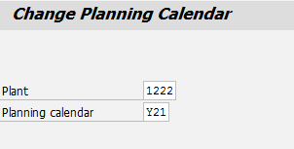
- Click on Periods
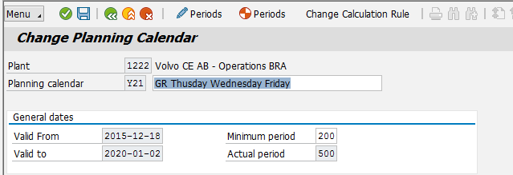

- Enter a new date in Valid to (+ 1 year) and press enter
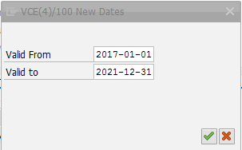

- Press Save
